Dream Analyzer 1.0

Overall dream experience

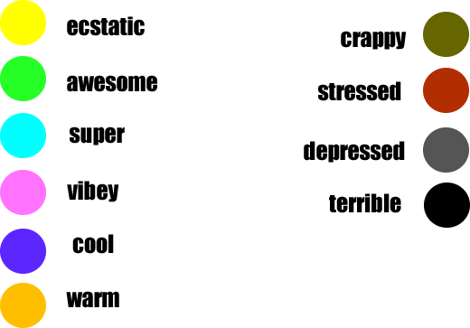

How are things are going for you generally in your daily life at the moment?



first time dream ( ) recurring dream ( )

Dream actors

You ( ) Partner ( ) Ex Partner ( ) Father ( ) Mother

Son ( ) Daughter ( ) Grandfather ( ) Grandmother ( )

Uncle ( ) Aunt ( ) Cousin ( ) Friend ( )

Boss ( ) Co worker ( ) Total Stranger ( )

Pet ( ) Animal ( ) Tree / plant ( )

Other - please state

Your role in the dream?

Carer ( ) lover ( ) teacher ( ) adventurer ( )

Supporter ( ) Message deliverer ( )

Worker ( ) Friend ( ) other - please state

Their role in the dream?

Carer ( ) lover ( ) teacher ( ) adventurer ( )

Supporter ( ) Message deliverer ( )

Worker ( ) Friend ( ) other - please state

Dream Theme

Love ( ) Compassion ( ) Tolerance ( )

Learning ( ) Support ( ) Teaching ( )

Desire ( ) Affection ( ) Sexuality ( )

Joy ( ) Ecstasy ( ) Adventure ( )

Betrayal ( ) jealousy ( ) Envy ( )

Anger ( ) violence ( ) Guilt ( )

Escape ( ) Trapped ( ) Isolation ( )

Other - please state

Dream environment

Same as normal daytime environment ( )

Inside bedroom ( )

Inside house ( ) Inside office ( )

Inside school ( ) Inside church ( )

Inside other - please list

City ( ) Surburban ( )

Park ( ) Ocean ( ) Inside earth ( )

Crowd ( ) Lake ( ) River ( )

Desert ( ) Forest ( ) Montain ( )

Sky / Upper atmosphere environment ( ) outer space environment ( )

Don’t know where it was? ( ) Other - please list

Dream Lighting

Intense lights / colours ( )

Normal ( )

Grey, barren expanse of nothing ( )

Dream Clarity

Heaven like bliss ( ) Super emotional HD ( ) Very clear ( ) Average ( ) Fuzzy ( ) Hard to make out ( )

Dream Power

Can glide fly ( ) can levitate ( ) can walk above the ground ( )

Can breath underwater ( ) Can change myself into other living things ( )

Experience telepathy ( ) can sing amazingly ( ) hear amazing sounds ( )

Can travel through solid objects ( ) teleport to other destinations ( )

Can build things by will ( ) Can destroy things by will ( )

Can see or communicate with persons who have passed ( )

Witness the past ( ) See future alternatives ( )

Can communicate with animals ( ) Can communicate with plants/ trees ( )

Attract wealth ( ) Good health ( )

Dream Blocks

Can’t walk ( ) can’t run ( ) can’t talk ( )

Can’t hear ( ) can’t breathe ( ) being chased ( )

Walking naked in front of people ( ) Can’t find something ( )

Lost friends ( ) Lost family ( ) Lost partner ( ) Lost children ( )

Poverty ( ) Illness ( ) Dying ( ) Dead ( ) Can’t think straight ( )

Dream Physics

Like normal waking day ( ) i

Atmosphere thicker and more viscous ( ) i

Super heavy gravity ( )i

Atmosphere watery ( )i

Atmosphere electric and humming ( )

Dream Lucidity

Woke up to soon ( ) Very lucid ( ) Mildly lucid ( ) Not lucid - Difficulty remembering ( )

Description of your dream

Insert text here